U.S. INTERNATIONAL CHRISTIAN ACADEMY
is an independent, international autonomous global high school institution

Serving students since 2001
Owned and Operated by Teachers
25 years of experience in Teaching and Administration
www.USICAhs.org
admin@USICAhs.org

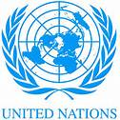
http://www.usicahs.org/Library.html
http://www.usicahs.org/Curriculum.html

U.S.I.C.A.Course Outline/Syllabus
Grade/Course: PHYSICAL SCIENCE 2003310
Grade Level: 9thHigh School
A)TEXT BOOK: PHYSICAL SCIENCE: CONCEPTS IN ACTION, WITH EARTH AND SPACE SCIENCE STUDENT EDITION 2004 [Hardcover]
PRENTICE HALL (Author)
ISBN-10: 0131663089 | ISBN-13: 978-0131663084
Order No.: 1 |  | Code:PHS2000 | Class Type:Online
Resources:  Text book  Teacher works CD Teacher interactive online  Links |  |  | Instructional Supports:  Textbook, Magazines, Journals, Websites Links, Conference, Comprehensive Reading Plan
Sky Conference |  | Length: 1 year
Area:Science |  | Credits: 1 | Total Numbers of class hours:300 hrs
Type: Mandatory |  | Standards:  Florida Sunshine State Standards | Prerequisite:  Students must have successfully passed a Science class in middle/high school.

B) Description:

This one-year course of Physical Science provides students with the essential skills experiences necessary to be successful in science. It is an introductory course designed for students to explore science in a setting. Topics covered: scientific method, laboratory methods, measurement, graphing, data types and interpretation, error analysis, presentation of scientific information, writing scientific research papers.

C) Objectives:

- To develop in all students an appreciation and understanding for Physical Science
- to develop in all students thinking skills in Science
- to promote the study of Physical Science

D) Contents

- Chapter 1Science Skills
- Chapter 2: Properties of Matter

- Chapter 3: States of Matter

- Chapter 4: Atomic Structure
- Chapter 5: The Periodic Table

  - Chapter 6: Chemical Bonds

Chapter 7: Chemical Reactions

- Chapter 8: Solutions, Acids, and Bases

- Chapter 9: Carbon Chemistry

Chapter 10: Nuclear Chemistry

Chapter 11: Motion
Chapter 12: Forces and Motion
Chapter 13: Forces in Fluids
Chapter 14: Work, Power, and Machines
Chapter 15: Energy
Chapter 16: Thermal Energy and Heat
Chapter 17: Mechanical Waves and Sound
Chapter 18: The Electromagnetic Spectrum Light
Chapter 19: Optics
Chapter 20: Electricity
Chapter 21: Magnetism

E. Methodology
E)Academic Methodology:

Tests | 30%
Writing Reports | 20%
Homework | 5%
Class Work | 20%
Reading Assignment | 25%

F) Book Reference:
1.HSPS09 READING AND STUDY WORKBOOK LEVEL A SE [Paperback] PRENTICE HALL (Author
2.Physical Science (Steck-Vaughn High School Science) Paperback– September 1, 2005
3.Physical Science / 2 Vol (P) (TE) Spiral-bound by R. Terrance Egolf and Rachel Santopietro (Author)by STECK-VAUGHN(Author)
4.PRENTICE HALL HIGH SCHOOL PHYSICAL SCIENCE CONCEPTS IN ACTION READING AND STUDY WORKBOOK 2006C Paperback– September 15, 2004 by PRENTICE HALL(Author)
5.Glencoe Physical Science, Laboratory Activities Manual, Student Edition (Glencoe Science) [Paperback] Glencoe McGraw-Hill (Author)
6.Glencoe Physical Science, Reinforcement and Study Guide, Student Edition [Paperback]
Glencoe McGraw-Hill (Author)

H) Web Reference:

www.flinnsci.com/.../physical-science-links
www.homelink.cps-k12.org/teachers/wrighka/hyperlinks2.html
www.myteacherpages.com/webpages/SMorrell/physical.cfm
www.linktoscience.schoolspecialty.com
www.wikipedia.com/physicalscience
www.sciencenetlinks.com
www.flinnsci.com/.../physical-science-links
www.homelink.cps-k12.org/teachers/wrighka/hyperlinks2.html
www.myteacherpages.com/webpages/SMorrell/physical.cfm
www.linktoscience.schoolspecialty.com
www.sciencenetlinks.com
http://www.physicsclassroom.com
http://www.everydaylearning.com/bscsblue
http://www.chemicalelements.com

I .Journals

Journal in Physical Science
Science Daily
American Scientist
Scientific American

J.Magazines:

Smithsonian magazine, published by the Smithsonian Museum
American Scientist magazine
Discover magazine

K. Organizations

National Science Foundation
National Teachers Science Associations

M. Comprehensive Reading Plan
Students are required to read at least 1 book or their equivalent during each class
as independent reading at-home. Students must also read for 30 minutes at home as part of their daily homework assignment in all subjects. Check your Class Reading Assignment at www.USICAhs.org/CURRICULUM and check free ebooks at www.openlibrary.org .

Text Book Description

Publication Date: December 15, 2004 | ISBN-10: 0131663089 | ISBN-13: 978-0131663084
Prentice Hall Physical Science: Concepts in Action helps students make the important connection between the science they read and the science they experience every day. Relevant content, lively explorations, and a wealth of hands-on activities help students understand that science exists well beyond the page and into the world around them.

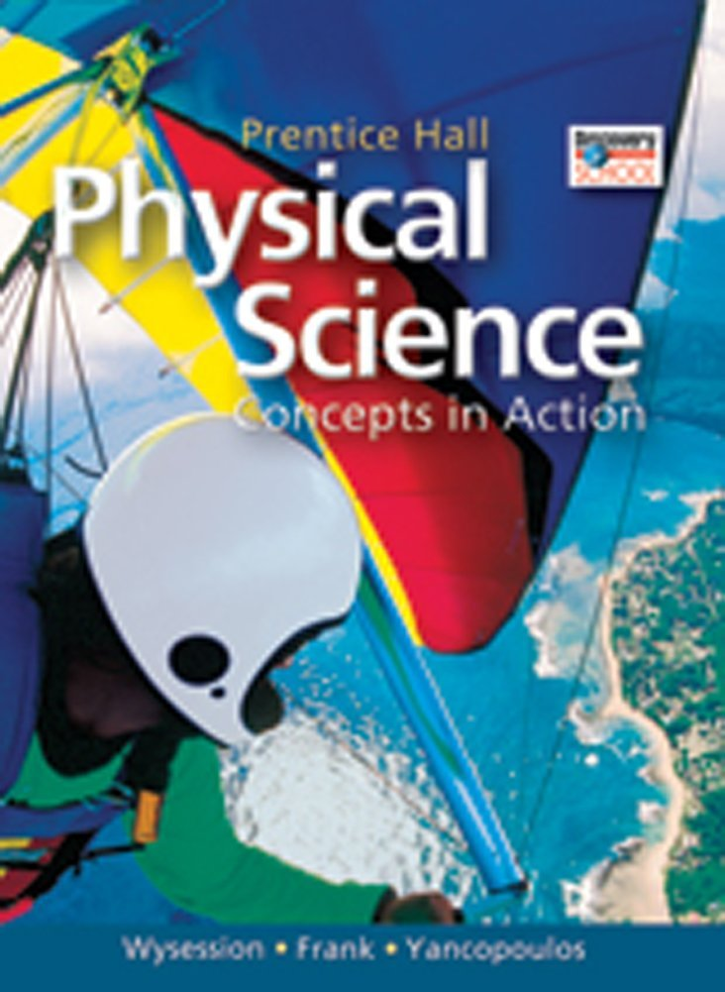

ACADEMIC MISCONDUCT:

Academic misconduct includes cheating (using unauthorized materials, information, or study aids in any academic exercise), plagiarism, falsification of records, unauthorized possession of examinations, intimidation, and any and all other actions that may improperly affect the evaluation of a student’s academic performance or achievement, or assisting others in any such act or attempts to engage in such acts. Academic misconduct in any form is inimical to the purposes and functions of the school and therefore is unacceptable and prohibited.
Any faculty member, administrator or staff member may identify an act of academic misconduct and should report that act to the department head or administrative supervisor.
Students violating the standards of academic honesty are subject to disciplinary action including reduction of a grade(s) in a specific course, assignment, paper, or project; a formal or informal reprimand at the professorial, dean, or academic vice president level; expulsion from the class in which the violation occurred; expulsion from a program; or expulsion from the school.

U.S. International Christian Academy © 2013
Revised on January 6 , 2020 USICA Copyright

