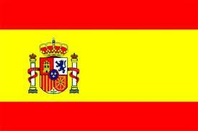

Hispanic Celebration
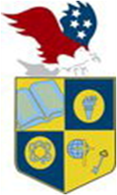
U.S. INTERNATIONAL
CHRISTIAN ACADEMY
is an independent, international autonomous
global high school institution

www.USICAhs.org
admin@USICAhs.org

Student Government Association
USICAsga@yahoo.com
Spanish Club “Viva Espana”
This club promotes an understanding of the Spanish culture, Literature,
Music and Customs.

USICASpanishClub@yahoo.com

