U.S. INTERNATIONAL CHRISTIAN ACADEMY
is an independent, international autonomous global high school institution

Serving students since 2001
Owned and Operated by Teachers
25 years of experience in Teaching and Administration
www.USICAhs.org
admin@USICAhs.org

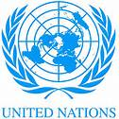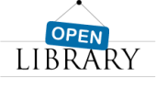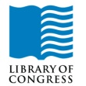
http://www.usicahs.org/Library.html
http://www.usicahs.org/Curriculum.html

Dear Students,
Reading Comprehensive Plan begins this week and should have already done their initial Reading test in Computers.
Students will be required to do readers each month. They have Monday-Sunday to get it done, and I will check to see that they completed their work the following Monday. This will be a Literature Homework grade.
Please know that technological issues will not be an excuse for not completing Reading Comprehensive, as the students have an entire week to find a computer and finish their assignments. My suggestion is that they begin every Monday or Tuesday. Please check the Syllabus at www.USICAhs.org/CURRICULUM
Thank you!

