U.S. INTERNATIONAL CHRISTIAN ACADEMY
is an independent, international autonomous global high school institution

Serving students since 2001
Owned and Operated by Teachers
25 years of experience in Teaching and Administration
www.USICAhs.org
admin@USICAhs.org

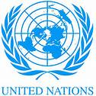
http://www.usicahs.org/Library.html
http://www.usicahs.org/Curriculum.html

U.S.I.C.A.Course Outline/Syllabus
Grade/Course:EARTH SPACE SCIENCE 200310
Grade Level: 10THHigh School
A)TEXT BOOK: Earth Science (Prentice Hall Science Explorer) [Hardcover]
PRENTICE HALL (Author)
ISBN-10: 0130626449 | ISBN-13: 978-0130626448
Order No.: 1 |  | Code:EAS2001 | Class Type:Online
Resources:  Text book  Teacher works CD Teacher interactive online  Links |  |  | Instructional Supports:  Textbook, Magazines, Journals, Websites Links, Conference, Comprehensive Reading Plan
Sky Conference |  | Length: 1 year
Area:Science |  | Credits: 1 | Total Numbers of class hours:300 hrs
Type: Mandatory |  | Standards:  Florida Sunshine State Standards | Prerequisite:  Students must have successfully passed a Science class in middle/high school.

B) Description:

This one-year course of emphasizes the study of Earth Science. Earth's profile and structure; water and the planet, groundwater, the atmosphere, weather and climate, clouds, precipitation, winds, forecasting, photosynthesis and respiration, seed plants and seedless plants, mammals, birds, insects, amphibians and reptiles.

C) Objectives:

- To develop in all students an understanding the exploring Earth’s Planet
- to develop in all students to investigate the nature of the universe and the plant
- to promote the study of astronomy, earth’s water, weather, climate, and earth’s changing surface.

D) Contents

Introduction to Earth Science
UNIT 1 Exploring Planet Earth
Chapter 1 Mapping Earth’s Surface
Chapter 2 Minerals
Chapter 3 Rocks

Interdisciplinary Explorations Gold –Noble
UNIT 2 Inside Earth
Chapter 4 Plate Tectonics
Chapter 5 Earthquakes
Chapter 6 Volcanoes

Nature of Science: Focus on Faults
UNIT 3 Earth’s Changing Surface
Chapter 7 Weathering and Soil Formation
Chapter 8 Erosion and Deposition
Chapter 9 A trip throughGeologic Time
Chapter 10 Energy Resources

Nature of Science:Mammals of Jurassic Period
UNIT 4 Earth’s Waters
Chapter 11 Fresh Water
Chapter 12 Freshwater Resources
Chapter 13 Ocean Motions
Chapter 14 Ocean Zones

Interdisciplinary Exploration: The Mississippi
UNIT 5 Weather and Climate
Chapter 15 The Atmosphere
Chapter 16 Weather Factors
Chapter 17 Weather Patterns
Chapter 18 Climate and Climate Change

Nature of Science: Eyes on Earth
UNIT 6 Astronomy
Chapter 19 Earth , Moon and Sun
Chapter 20 The Solar System
Chapter 21 Stars, Galaxies and the Universe

E. Methodology
E)Academic Methodology:

Tests | 30%
Writing Reports | 20%
Homework | 5%
Class Work | 20%
Reading Assignment | 25%

F) Book Reference:
1.Earth Science for High School [Kindle Edition] CK-12 Foundation (Author)
2. High School Earth Science Review (Review Smart) [Paperback] Michael Bentley (Author)
3.HIGH SCHOOL PHYSICAL SCIENCE: CONCEPTS IN ACTION W/EARTH & SPACE SCIENCE STUDENT EDITION [Hardcover] PRENTICE HALL (Author)
4.Earth Science (13th Edition) [Hardcover]by Edward J. Tarbuck, Frederick K. Lutgens and Dennis G Tasa (Authors)
5.Applications and Investigations in Earth Science (7th Edition) [Spiral-Bound] by Edward J. Tarbuck, Frederick K. Lutgens, Dennis G Tasa and Kenneth G. Pinzke (Authors)

H) Web Reference:

http://newyorkscienceteacher.com/sci/pages/links/es.php
http://highered.mcgraw-hill.com/sites/0072482621/student_view0/interactives.html#
http://earthsci.org/links/links.html
www.worldvolcanoes.info
www.internet4classrooms.com/earthspace.htm
www.ncsu.edu/imse/1/earth.htm
www.bownet.org/lneal/earth_science_links.htm
www.uky.edu/KGS/education/edustandalpha.htm
http://en.wikipedia.org/wiki/Earth_science
http://epod.usra.edu/blog/links.html
http://www.marlimillerphoto.com/geopix.html
www.mp.k12.wi.us/faculty/dvangalen/Earth_Science_Links.cfm
www.geology.com
www.flinnsci.com/.../physical-science-links
www.homelink.cps-k12.org/teachers/wrighka/hyperlinks2.html
www.myteacherpages.com/webpages/SMorrell/physical.cfm
www.linktoscience.schoolspecialty.com
www.sciencenetlinks.com
http://www.physicsclassroom.com
http://www.everydaylearning.com/bscsblue

I .Journals

Journal in Earth Science
Science Daily

J.Magazines:

Smithsonian magazine, published by the Smithsonian Museum
American Scientist magazine
Discover magazine

K. Organizations

National Science Foundation
National Science Teachers Association

M. Comprehensive Reading Plan
Students are required to read at least 1 book or their equivalent during each class
as independent reading at-home. Students must also read for 30 minutes at home as part of their daily homework assignment in all subjects. Check your Class Reading Assignment at www.USICAhs.org/CURRICULUM and check free ebooks at www.openlibrary.org

Text Book Description:

Publication Date: April 20, 2001 | ISBN-10: 0130626449 | ISBN-13: 978-0130626448
Lead author Michael Padilla weaves together content with hands-on science inquiry that's sure to reach everystudent.

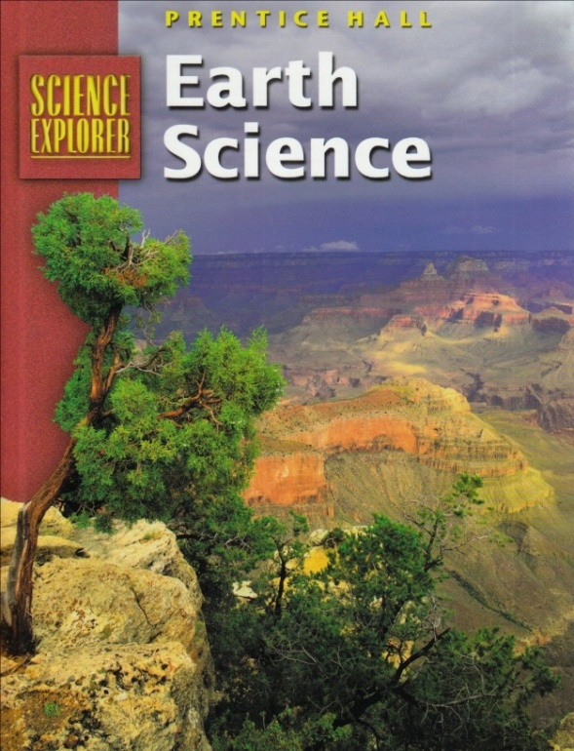

ACADEMIC MISCONDUCT:

Academic misconduct includes cheating (using unauthorized materials, information, or study aids in any academic exercise), plagiarism, falsification of records, unauthorized possession of examinations, intimidation, and any and all other actions that may improperly affect the evaluation of a student’s academic performance or achievement, or assisting others in any such act or attempts to engage in such acts. Academic misconduct in any form is inimical to the purposes and functions of the school and therefore is unacceptable and prohibited.
Any faculty member, administrator or staff member may identify an act of academic misconduct and should report that act to the department head or administrative supervisor.
Students violating the standards of academic honesty are subject to disciplinary action including reduction of a grade(s) in a specific course, assignment, paper, or project; a formal or informal reprimand at the professorial, dean, or academic vice president level; expulsion from the class in which the violation occurred; expulsion from a program; or expulsion from the school.

U.S. International Christian Academy © 2013
Revised on FEB 15, 2016 USICA Copyright

